Exterior Region
# Source: AI Source: Provided by: [Data Path: Persons Table -> ID Column: 1, Name_En Column: Motasem Essam] -> From: [ChatGPT] on [7/25/2026]
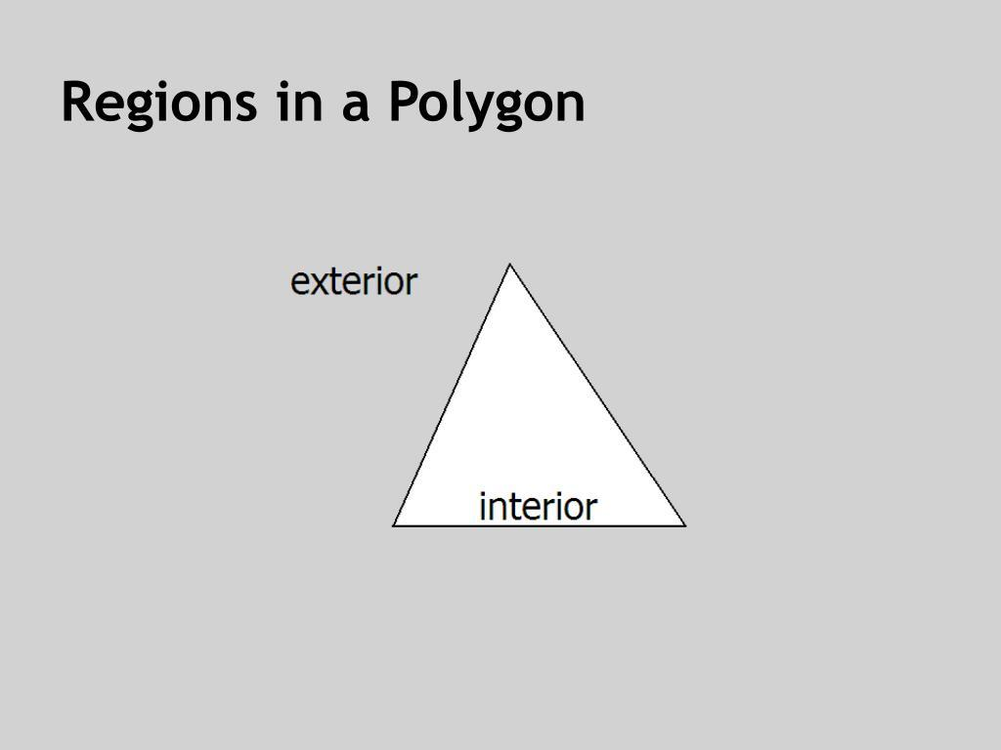
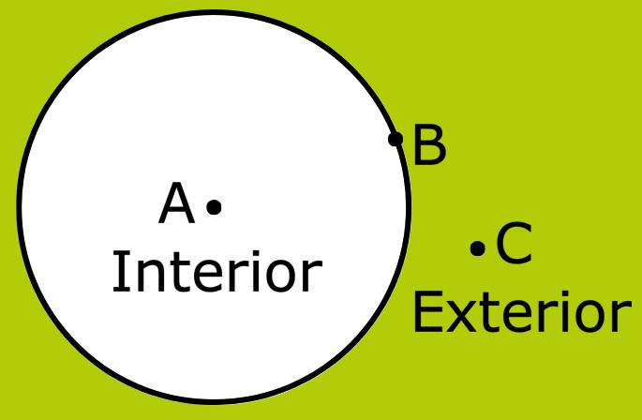
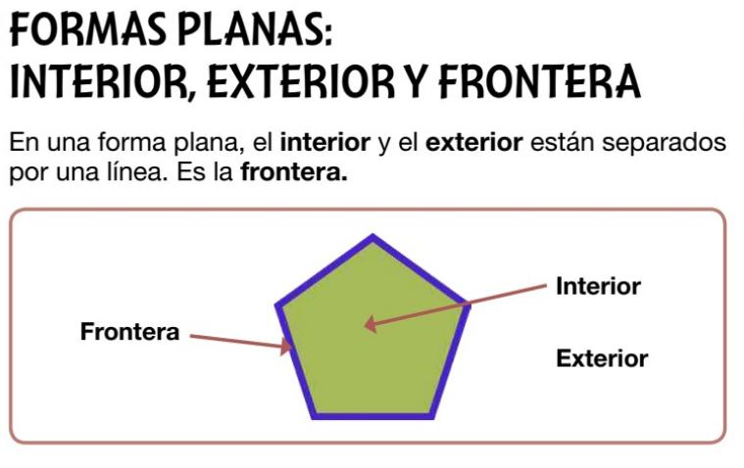
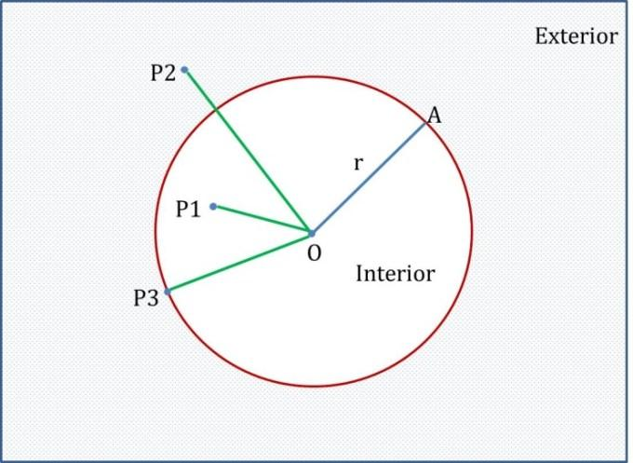
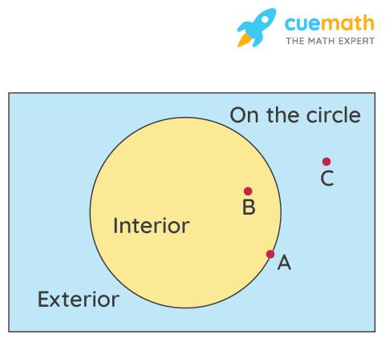
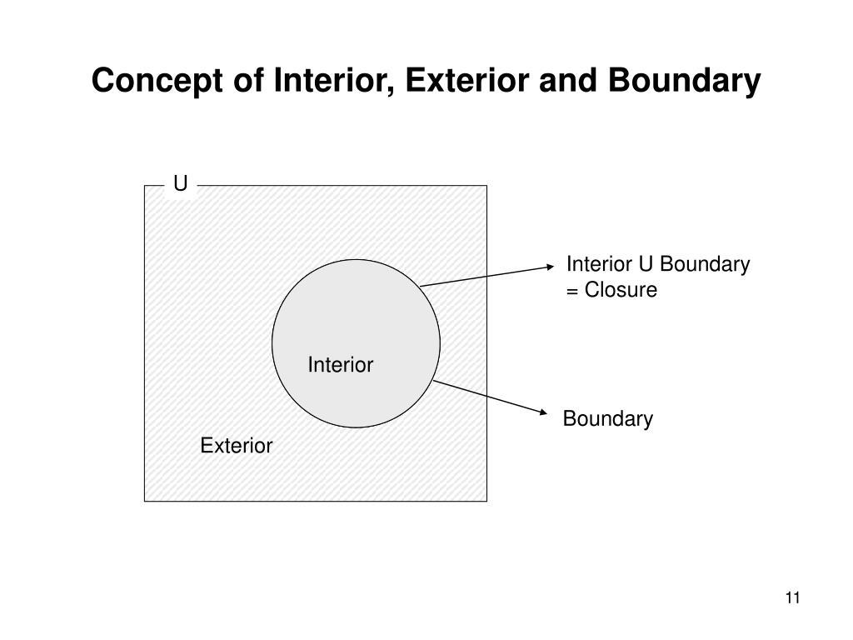

Definition
# Source: AI Source: Provided by: [Data Path: Persons Table -> ID Column: 1, Name_En Column: Motasem Essam] -> From: [ChatGPT] on [7/25/2026]
An Exterior Region is the set of all points that lie outside a closed geometric figure. It consists of every point that is not inside the figure and not on its boundary.
The exterior region extends infinitely in all directions beyond the boundary of the figure.

Characteristics
# Source: AI Source: Provided by: [Data Path: Persons Table -> ID Column: 1, Name_En Column: Motasem Essam] -> From: [ChatGPT] on [7/25/2026]
An exterior region:
- Lies completely outside a closed figure.
- Is separated from the interior by the boundary.
- Does not include the boundary in the strict mathematical definition.
- Extends infinitely in one or more directions.
- Contains infinitely many points.
- Is an unbounded region.

Illustration

Exterior of a Rectangle
# Source: AI Source: Provided by: [Data Path: Persons Table -> ID Column: 1, Name_En Column: Motasem Essam] -> From: [ChatGPT] on [7/25/2026]
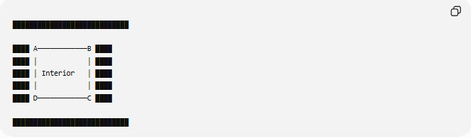
████████████████████████████

████ A────────────B ████
████ │ │ ████
████ │ Interior │ ████
████ │ │ ████
████ D────────────C ████

████████████████████████████
The shaded area outside the rectangle represents the exterior region.

Exterior of a Circle
# Source: AI Source: Provided by: [Data Path: Persons Table -> ID Column: 1, Name_En Column: Motasem Essam] -> From: [ChatGPT] on [7/25/2026]
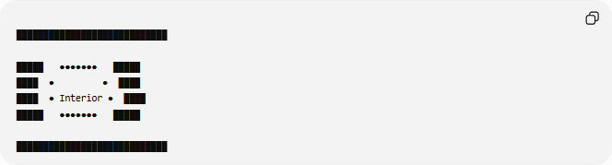
████████████████████████████

█████ ●●●●●●● █████
████ ● ● ████
████ ● Interior ● ████
█████ ●●●●●●● █████

████████████████████████████
The shaded region outside the circle is the exterior region.

Mathematical Representation
# Source: AI Source: Provided by: [Data Path: Persons Table -> ID Column: 1, Name_En Column: Motasem Essam] -> From: [ChatGPT] on [7/25/2026]
Suppose the boundary of a figure is:
$$∂R$$
and its interior is:
$$\operatorname{Int}\left(R\right)$$
Then the exterior consists of all points that satisfy neither condition.

Example
For a circle:
Interior:
$$x^{2}+y^{2}<r^{2}$$
Boundary:
$$x^{2}+y^{2}=r^{2}$$
Exterior:
$$x^{2}+y^{2}>r^{2}$$

Examples
# Source: AI Source: Provided by: [Data Path: Persons Table -> ID Column: 1, Name_En Column: Motasem Essam] -> From: [ChatGPT] on [7/25/2026]
Example 1 – Triangle
Every point outside the three sides of a triangle belongs to the exterior region.

Example 2 – Rectangle
Everything outside the four edges is part of the exterior region.

Example 3 – Circle
All points satisfying
$$x^{2}+y^{2}>r^{2}$$
belong to the exterior region.

Exterior Region vs Interior Region
# Source: AI Source: Provided by: [Data Path: Persons Table -> ID Column: 1, Name_En Column: Motasem Essam] -> From: [ChatGPT] on [7/25/2026]
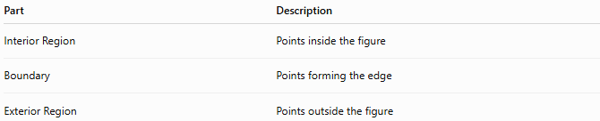
Part | Description
Interior Region | Points inside the figure
Boundary | Points forming the edge
Exterior Region | Points outside the figure

Exterior Region and Area
# Source: AI Source: Provided by: [Data Path: Persons Table -> ID Column: 1, Name_En Column: Motasem Essam] -> From: [ChatGPT] on [7/25/2026]
Unlike an interior region, the exterior region:
- Extends infinitely.
- Does not have a finite area.
- Is considered an unbounded region.

Real-World Examples
# Source: AI Source: Provided by: [Data Path: Persons Table -> ID Column: 1, Name_En Column: Motasem Essam] -> From: [ChatGPT] on [7/25/2026]
Exterior regions include:
- Land outside a fenced property.
- Space outside a building.
- The area surrounding a lake.
- Air surrounding a balloon.
- The region outside a country's border.
- Open space around a sports field.

Applications
# Source: AI Source: Provided by: [Data Path: Persons Table -> ID Column: 1, Name_En Column: Motasem Essam] -> From: [ChatGPT] on [7/25/2026]
Exterior regions are used in:
- Plane Geometry
- Coordinate Geometry
- Analytic Geometry
- Topology
- Engineering
- Architecture
- Surveying
- GIS (Geographic Information Systems)
- CAD (Computer-Aided Design)
- Computer Graphics

Advantages
# Source: AI Source: Provided by: [Data Path: Persons Table -> ID Column: 1, Name_En Column: Motasem Essam] -> From: [ChatGPT] on [7/25/2026]
Studying exterior regions helps to:
- Describe regions outside objects.
- Solve geometric inequalities.
- Analyze boundaries.
- Model surrounding space.
- Support spatial reasoning in engineering and mapping.

Limitations
# Source: AI Source: Provided by: [Data Path: Persons Table -> ID Column: 1, Name_En Column: Motasem Essam] -> From: [ChatGPT] on [7/25/2026]
An exterior region:
- Exists only relative to a closed figure.
- Is infinite.
- Does not include the boundary in the strict mathematical definition.

Comparison with Related Concepts
# Source: AI Source: Provided by: [Data Path: Persons Table -> ID Column: 1, Name_En Column: Motasem Essam] -> From: [ChatGPT] on [7/25/2026]
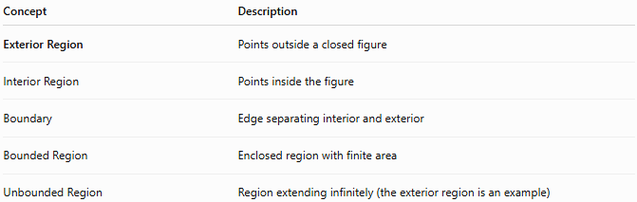
Concept | Description
Exterior Region | Points outside a closed figure
Interior Region | Points inside the figure
Boundary | Edge separating interior and exterior
Bounded Region | Enclosed region with finite area
Unbounded Region | Region extending infinitely (the exterior region is an example)

Key Points
# Source: AI Source: Provided by: [Data Path: Persons Table -> ID Column: 1, Name_En Column: Motasem Essam] -> From: [ChatGPT] on [7/25/2026]
- An Exterior Region contains all points outside a closed figure.
- It is separated from the interior by the boundary.
- The strict definition excludes the boundary.
- It extends infinitely.
- It is an unbounded region.

Conclusion
# Source: AI Source: Provided by: [Data Path: Persons Table -> ID Column: 1, Name_En Column: Motasem Essam] -> From: [ChatGPT] on [7/25/2026]
An Exterior Region is the set of all points lying outside a closed geometric figure, separated from the interior by the figure's boundary. It extends infinitely and is therefore an unbounded region. Exterior regions are fundamental in plane geometry, coordinate geometry, analytic geometry, topology, engineering, architecture, surveying, GIS, CAD, and computer graphics, where they are used to describe surrounding space, define solution sets of inequalities, analyze spatial relationships, and model environments beyond enclosed objects.

